Ignite Hoodie Order Form

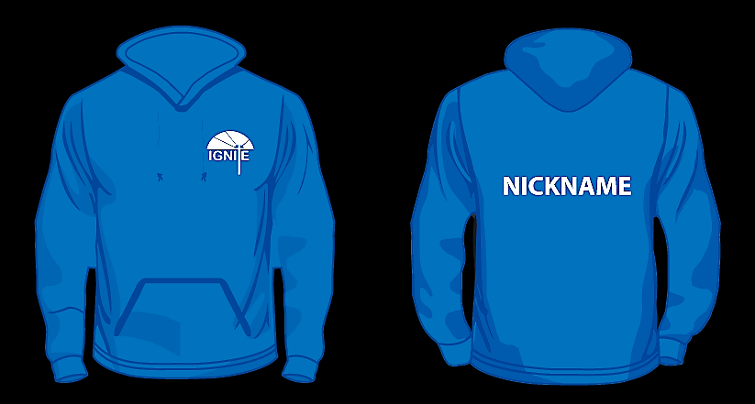

Choose between the Zipped Hoodie (£16.00) or the no zip Hoodie (£15)
Choose which colour
Choose which size XS (33”) S (36”) M (39”) L (42”) XL (45”) XXL (49”) XXXL (52”)
Choose whether you would like your name or nickname on the back or if you would like it left blank

Give Diane your choices and payment (preferably a cheque made payable to ‘Soul Edge’) by February 10th

Don’t know what to do with your Christmas money!

Early Easter Present!

We’ve got it all zipped up!

Order an Ignite Hoodie!

